# **Team communication**

Effective communication is crucial to agile. Communication among team members develops cooperation, explains every stage of the project lifecycle, and enhances general awareness of requirements (Teamrg.com, 2022). Communication is essential for collaboration and maintaining partnerships with stakeholders. In everyday meetings, communication stresses the importance of in-person interactions over written communications, cooperation over negotiation, and in-person interactions over processes. Lack of communication may lead to additional difficulties that might have been avoided as well as unnecessary costs or delays. Regular and effective communication is the greatest approach to ensure that every member of an agile team is aware of the design for the current deliverables. Through clear communication, the team may avoid "coding like hell" and rework that may result from misunderstandings of the requirements. As an outcome, the solution is provided more quickly, more effectively, and accurately while keeping each team member's strategic aim front of mind.

## **Video conversation**

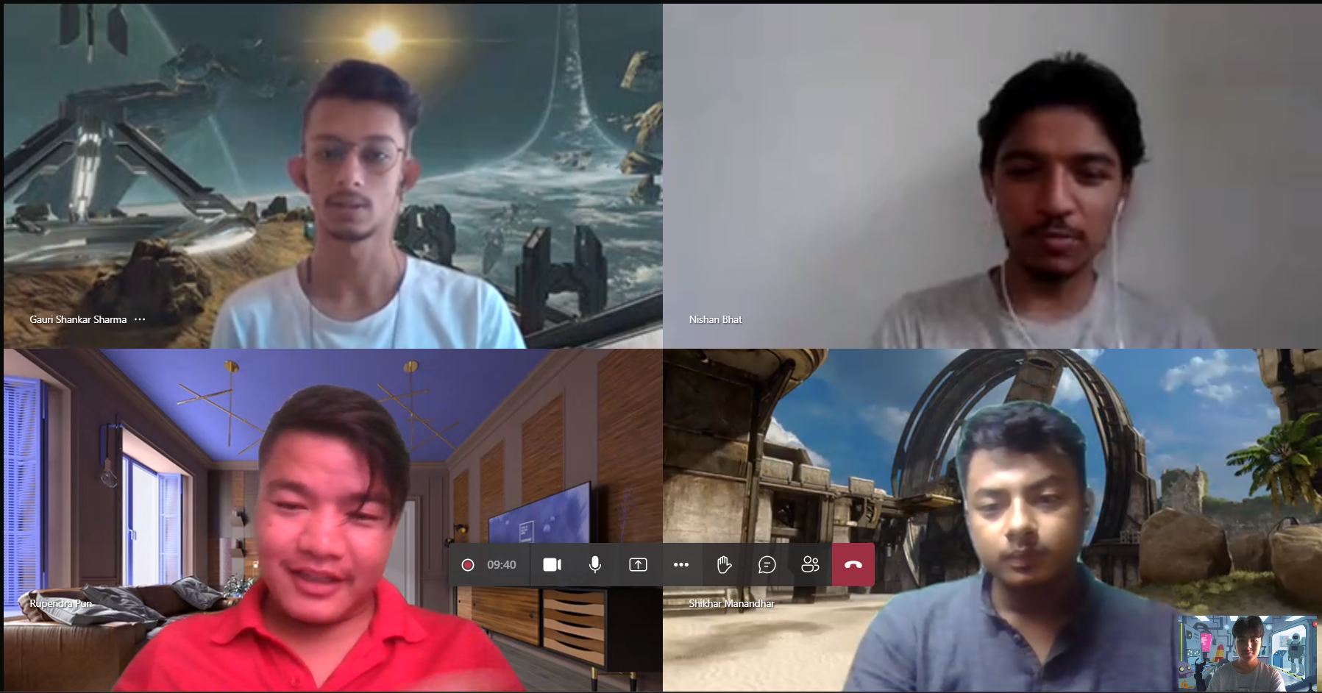

During our daily standup meetings, we choose to conduct virtual conversations using Microsoft Teams. Although there are other options for communication, such as Messenger, but we discover that Microsoft Teams is more practical for scheduling meetings, taking part in conversations, and sharing ideas. It is simpler to set up and use Microsoft Team. It is accessible from both PCs and mobile devices. Its versatility allowed us to take part in meetings whenever we wanted, even if the power went out or our laptop battery ran out. Each team member addressed problems, shared concepts, and provided updates on their own performance. Microsoft Teams was used to host a variety of meetings, including daily standups, backlog grooming, sprint reviews, and retrospective sessions. These meetings gave us an opportunity to sharpen our focus, improve our communication, and be open to honest feedback. (AgileModeling.com, 2022)

## **Face-to-face communication**

Face-to-face communication meetings were organized to address any misunderstandings that a video conference between team members was unable to address. Everyone was present at this meeting in person. Following that, all team member discusses their concerns with the project. After team members have had a chance to discuss the problem, a solution is proposed. To ensure that everyone could participate, we organized in-person sessions on college premises throughout the completion of project. We spent the majority of our time in in-person meeting focusing on coding issues. This technique of communication has been found to be far more successful than other approaches. This meeting benefitted us by providing rapid replies, solid working connections, enhanced productivity, minimized misunderstandings, and boosted team participation.(Marketing91, 2022)

## **Phone conversation**

When a team member was unable to attend a meeting, both physically and virtually, we held phone-to-phone conservation. This meeting was exceptional because all team members were dedicated to completing the project. This meeting has a relatively short time span (1-2 min). If team member A is unable to attend a meeting, team member B contacts the absent team member A and briefly describes the plan. As a result, conservation comes to an end. This is known as phone conservation. This strategy is the least effective of all. Because the video cannot be seen, one team member will not know what another team member is doing.

# **Communication theory**

According to the study, there are three communication theories: classical communication theory, human relations communication theory, and open system communication theory. The classical theory of communication is a top-down technique in which the principle (team leader) issues orders to the instructors (team members), and the instructors give feedback to the principle on the effectiveness of their task. According to the Human Relations Theory of Communication, both the sender and receiver must work hard to understand the inaccuracies and loopholes that frequently arise between perceiving and receiving messages. Furthermore, the transfer of messages and meaning between an institution and its surroundings, as well as between its networks of interdependent subsystems, is described by open system theory of communication. As a communication theory, classical communication theory has been adopted. As team leader, the scrum master assists the rest of the team to finish the job. The team's communication is also formed in structured, hierarchical, and scheduled way. This strategy is appropriate for scrum since we schedule a sprint review meeting at the end of each daily scrum meeting to summarize our progress and submit the feature to the scrum master. If a team member fails to finish a job, the scrum master is informed. The scrum master then proposes a method to accomplish the task within the timeframe. As a result, job efficiency became maximized, and a small portion of usable product was delivered to the user. (World’s Largest Collection of Essays! Published by Experts, 2022)

# **Issue of communications**

There were some few issues during team communication. However, we would to resolve it though it may take some time. For e.g., if there is no electricity during the meeting then we would either shift meeting for few minutes or hour till electricity. Each team member is connected to each other in different social media platform such as Messenger, Viber, etc. But when we try to contact them so share important information, few team member didn’t respond to the message. This issue slowed down team productivity. Another issue was the internet. Due to the poor internet connectivity few team member were unable to attend meeting so he had to use mobile data to join the meeting. Most of the time we set up physical meeting so that everyone can stay together and do their work. Occasionally during important conservation, few team member had to leave meeting early. This caused conflict in team, which later on was resolved. Hence even there were issue any issue during the communication the team members would actively act and solve the issue.

# **Why scrum**

Scrum is a teamwork methodology. Scrum enables developers to learn through experiences, self-organize while working on a project, and reflect on their wins and losses in order to improve overall. Software development teams are by far the most likely to use the scrum approach. Its concepts and lessons are suitable for any type of communication. This is one of the reasons behind the popularity of scrum. Scrum is a set of meetings, tools, and responsibilities that help teams plan and reach their goals. Alteration may be encouraged and included into an ongoing project. The project scope is dynamic in a scrum, but the time and cost are fixed. There is no manager in a scrum team to tell them what to do or when they should interact more with the project like their own. Instead of a manager, they have a scrum master who guides members and ensures them from unwanted stress. Furthermore, because of methods like pair programming, their level of acquiring knowledge becomes higher and can programmed alone which results in faster coding completion time with better quality. Customer satisfaction is also higher when a project is carried using the scrum methodology. Users get functioning portions of full products more quickly. They can then put what they've got to the test and report back on their results. This is a critical factor in the project's overall performance. The user may discover that changes to his or her request for work to be done are required. If this occurs, there should be no difficulty because Scrum is built for adaptation and the rapid acceptance of change. (Why Scrum, 2022)

# **Retrospective meeting**

(Workfront.com, 2022)

The sprint retrospective is a routine meeting held at the completion of a sprint to evaluate what went well during the previous sprint cycle and what may be improved for the next sprint. The retrospective sprint is an essential component of the Scrum methodology for planning, implementing, and managing large projects. Everything that impacts the Scrum team's ability to develop the product is open to debate and change, including techniques, tools, documents, environment, and so on. It enables development teams to modify Scrum to their own needs. The retrospective meeting ensure that essential adjustments are acknowledged and implemented before they are forgotten in the bunch of new tasks. It allows each scrum team member in identifying how they may improve the particular tasks they made contributions to the sprint. Each retrospective meeting usually lasts around one hour. The following are the main questions raised at the meeting.

What went well in this sprint?

What went wrong in the spring?

How should the next sprint play out?

What did we learn?

During each agile sprint retrospective, the development team focuses on increasing product quality by improving work process. The picture shown below is retrospective sprint sheet of each week

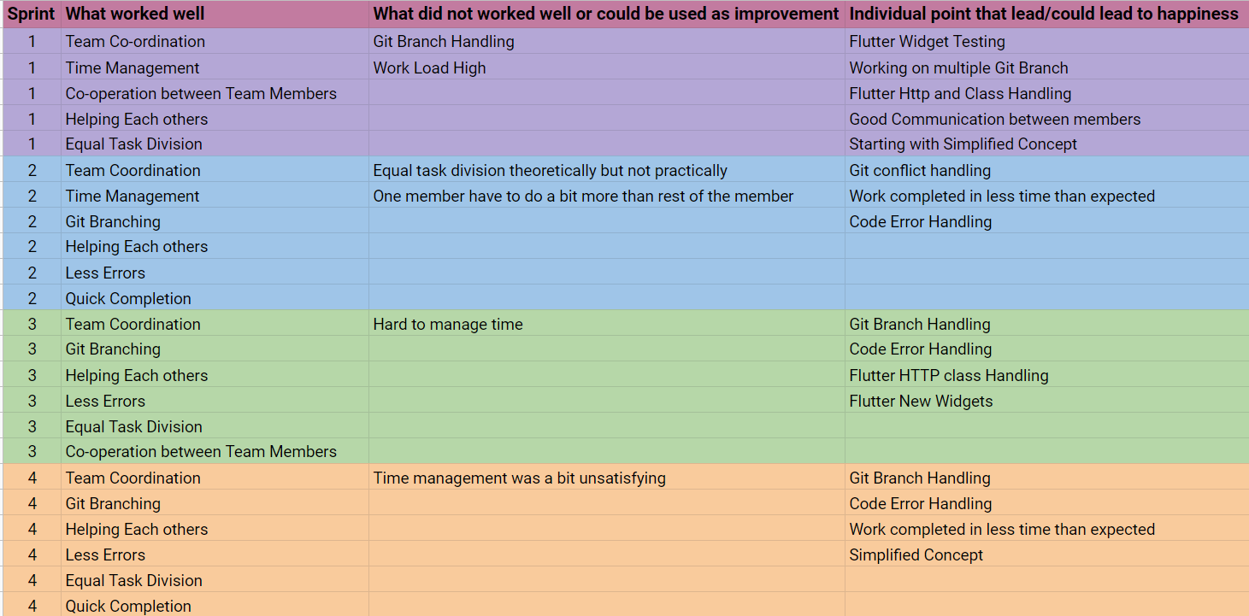

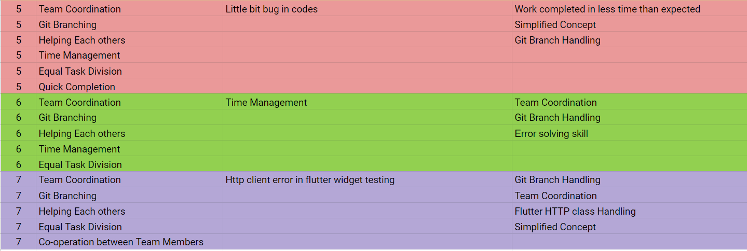

8th sprint ko baki xa ….